December 14, 2020

Groton Planning Board
Town Hall
Groton, MA 01450

RE: Village at Shepley Hill

Dear Takashi and Members of the Planning Board,

I am writing as an individual, not as a Trustee of the Groton Conservation Trust nor in any other capacity, relative to the recently submitted Village at Shepley Hill Definitive Subdivision.

In reviewing the Definitive Plans for this project, I note that there are numerous locations where cuts and fills within the proposed rights of way exceed seven feet. Section 381-10-D-(5) of the Subdivision Regulations states "Proposed grades within the right-of-way, including the cul-de-sac, shall not be more than seven feet above or below existing grade unless specifically authorized by the Board in unusual topographic circumstances."

A review of the road profiles indicates that the seven-foot cut and fill limitations are violated for distances of hundreds of feet and in some locations with cuts or fills more than 20 feet. A waiver has been requested stating "This request is necessary due to the varied and unusual topography of the Property and is the only way to properly and safely accommodate the installation of the Roadways and wetland crossings."

I would note first of all that there is nothing "unusual" about the topography of this site in Groton. This property includes one of 39 drumlin hills in Groton. It is likely that every one of those drumlins has portions where the seven foot limitations on cuts and fills for roads cannot be met. There are also literally hundreds of kame, kettle, esker and glacial lake edge landforms in Groton with portions where the limitations cannot be met. The seven foot cut and fill limitations do not mean that properties with such landforms cannot be developed, it means they must be developed in ways that respect, and conform with, the natural topography.

This Subdivision Regulation has been in place for more than 40 years and is one of the most important regulations in maintaining the natural appearance and visual character of Groton. Groton has one of the most remarkable arrays of glacial landforms anywhere. These landforms create the varied, undulating topography that is the basis of Groton's natural landscape and must not be violated to the extent presented on these plans.

With respect to the portion of the waiver request that states "this is the only way to properly and safely accommodate the installation of the Roadways and wetland crossings", granting a waiver under this rational would create a precedent that would open the door to numerous types of similar waiver requests on other subdivisions. Roadways should be designed to respect the landscape and minimize waiver requests, even if that means maximum densities cannot be achieved.

I would like to note that I had the opportunity to walk the property and discuss the proposed subdivision on October 22nd with Larry Smith, Julia Dickinson and their engineer. All were extremely helpful and accommodating. I would also note that I am supportive of having different types of housing in Groton, such as that proposed for this property. However, I feel the damage to our local landscape and the extraordinary degree of violation of an essential subdivision regulation proposed in this project should not be approved. I urge the Planning Board to deny this waiver request.

Respectfully,
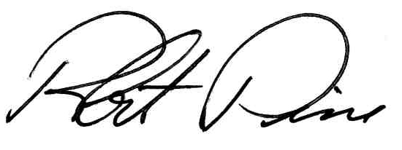
Robert Pine, PE FASLA

cc. Larry Smith
Julia Dickinson
George McGovern
Hugh McGovern
Groton Conservation Trust
Claire and Roy Wilson
Groton Conservation Commission

